This template is a resource for 3R streamlined design exception documentation.
Project Description. Small structure replacement, located on SR 32 over Stoney Creek, 1.8 miles east of SR 13, in Madison County, Indiana.
TRAFFIC DATA |  | SR 32
Construction Year AADT | 2015 | 6540 | VPD
Design Year AADT | 2035 | 7360 | VPD
Percent Trucks |  | 3 | % AADT
DESIGN DATA
Design Speed |  |  | MPH
Project Design Criteria
Functional Classification
Rural / Urban
National Highway System (NHS) Route
National Truck Network (NTN) Route

Design Feature. A Level One Design Exception is requested to address the following design elements(s):

Design Element | Required Value | Proposed Value | Existing Value
 | 8 ft | 6 ft | 6 ft
Design Criteria Ref. IDM Fig. 55-3A

☒ Supporting design calculations and plan sheets are included in the appendix.

Additional Considerations
(check where applicable. Add comments as needed)
☐ Meeting the required value will require R/W acquisition.

☐ Meeting the required value will have impacts to scenic, historic, or environmental features.

Crash Analysis. [Note: showing crash locations on a map is incredibly helpful. Data should be compiled 500-1000 ft either side of the project. In general, the analysis is looking at crash patterns and if they are correctable by improving the design element (to standard or incrementally). If a pattern is identified, then we need to determine if this is the project to take that work on and document the decision.] Crash narratives are the most useful in establishing probable cause and relationship to geometric elements. If crash data provided by district is more than 5 years old, confirm with district that there have been no notable changes along the route.
For MOT applications, the existing crash data may not be directly applicable during MOT; however existing crash patterns may continue to be problematic or be exacerbated during MOT and should be discussed.
Crash data from 2012 to 2014 was compiled. The extents encompass SR 32 from the intersection of SR 13 to S. CR 925 W, approximately 2500 ft. The project limits are approximately 400 feet, 1.8 miles northeast from SR 13 to 1000 feet southwest of CR 925 W (Main St). A summary of the number of crashes, severity, and manner of collision is below. See Crash Map in appendix.
Year | Fatality/Incapacitating Injury | Non-Incapacitating Injury | Property Damage Only | Manner of Collision | Comments
2012 | 0 | 0 | 1 | ROR | Deer
2013 | 0 | 0 | 0
2014 | 0 | 0 | 1 | Rear End | Driver impairment

An evaluation of the crash data reveals the following conclusions (Select at least one option):
☐ 1. No crashes within the extents noted.

☒ 2. There were 2 crashes within the extents noted. These crashes were noted as deer a deer hit and driver impairment and do not represent a pattern related to the substandard shoulder.

☒ 3. Crash data was entered into the Department’s Road Hazard Analysis Tool (RoadHAT). There were 2 crashes in the project vicinity. The Index of Crash Frequency (I_{CF}) and Index of Crash Cost (I_{CC}) are shown below. Values of 0 or less indicate the roadway is performing statistically better than expected compared to similar roadways in Indiana.
I_{CF} = -.58 I_{CC} = -.75
☐ 4. There were crashes in the project vicinity, but the Benefit / Cost Ratio is Less than 1.0
Benefit / Cost Ratio =
The roadway segment has had no severe crashes and is currently performing statistically better than expected compared to similar roadways in Indiana. The crashes do not indicate a pattern that could be addressed by widening the shoulder.

The Crash Modification Clearinghouse estimates increasing the shoulder from 6 ft to 8 ft would result in a 4 % reduction in all crash types. However, widening the shoulders an additional 2 ft to meet the required value would create a local discontinuity in the roadway cross section and would not yield significant benefit for such a short segment of roadway. In addition, soft soils in the area may be problematic for a narrow widening.

Plans for Expansion. [District correspondence can be included in an appendix] Greenfield District Technical Services indicated an intersection improvement project is planned at the intersection of SR 13 and SR 32, but that there are currently no plans for expanding SR 32 to increase capacity or for overall corridor improvement. INDOT Corridor Development Office confirmed that SR 32 is not currently being evaluated for expansion.
Compatibility with Adjacent Sections. The proposed cross section matches the existing cross section. The cross section is consistent from the intersection with SR 13 to the urban boundary of the City of Anderson.
Mitigation Measures. [Note: Do not “suggest” mitigation measures for the current project or future projects or list all possible measure from the FHWA Mitigations Strategies document. Measures noted should be included on the plans or otherwise incorporated in the contract. It’s ok to discuss measures that were considered but dismissed. This is often (but not always!) the case for very short projects because there is limited benefit over such a short distance. Guardrail is not a mitigation measure for substandard geometrics in and of themselves. Coordination with district Traffic Engineer for signs, enhanced pavement markings, rumble strips/stripes, etc. should occur prior to submitting the DE.] Edgeline pavement markings will be replaced in kind. Edgeline rumble stripes were considered but not included due to the short project length.

Attachments/Appendix [The design exception request must contain all the necessary information or references without requiring the reviewer to obtain additional information (e.g., plan sheets, copies of pages of this Manual that pertain to the design exception request, or copies of pertinent pages of the AASHTO Policy on Geometric Design of Highways and Streets, correspondence, raw traffic data.)
- Plans (Include Title sheet, typical section, P&P/Layout, structure details, note location of DE)
- Source of geometric criteria (IDM, GreenBook)
- Site photos (for context – see example next pages)
- Crashes plotted on a map (see next pages for example)
- RoadHAT reports (where appropriate. If there are zero crashes, RoadHAT is not needed). Discuss what ICF and ICC means. Comparisons are to similar roadways in Indiana.

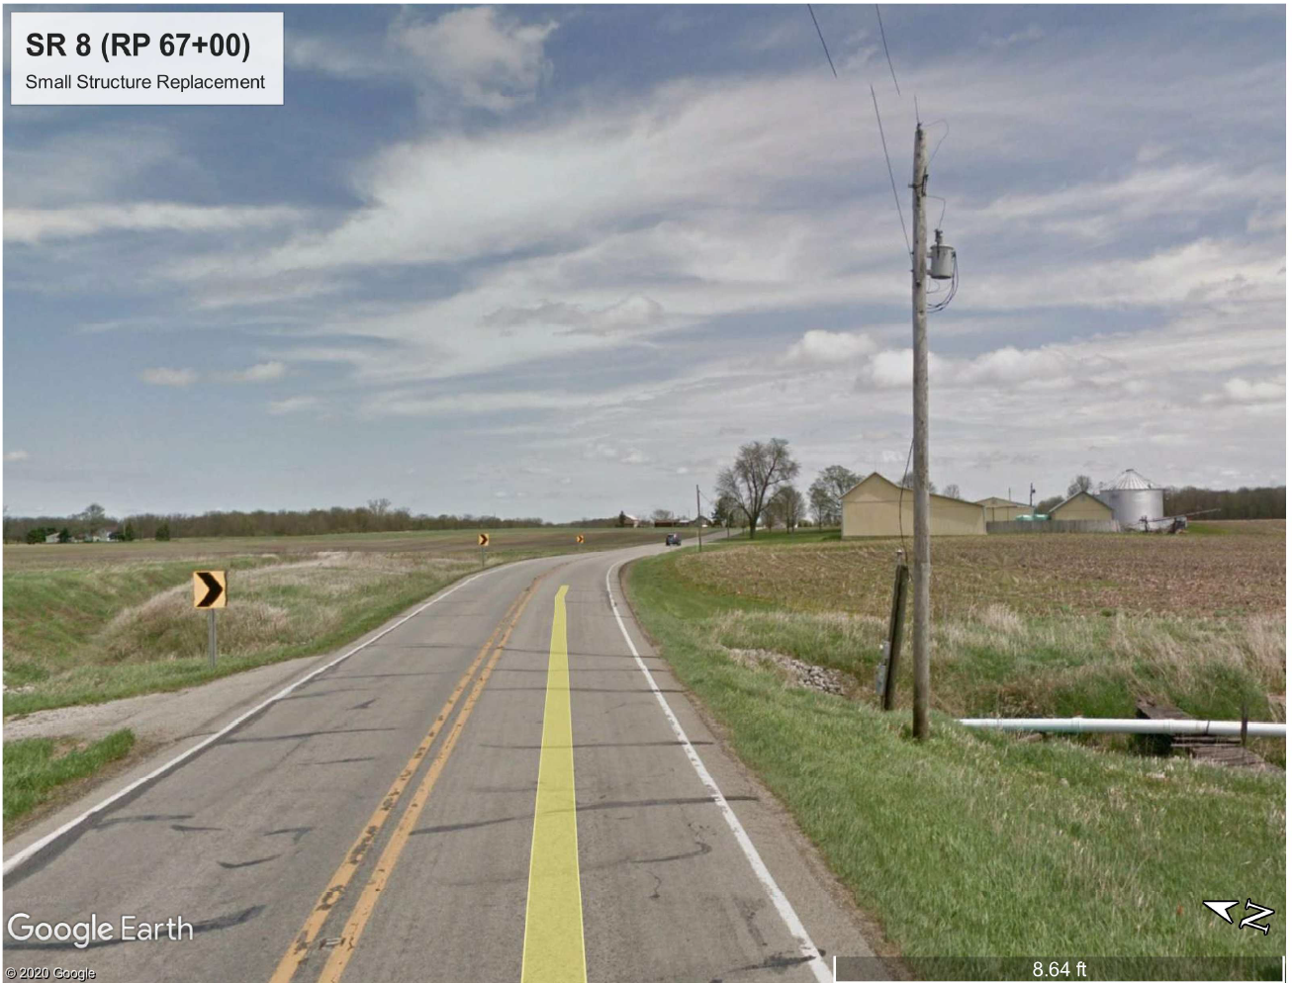
Site photo example
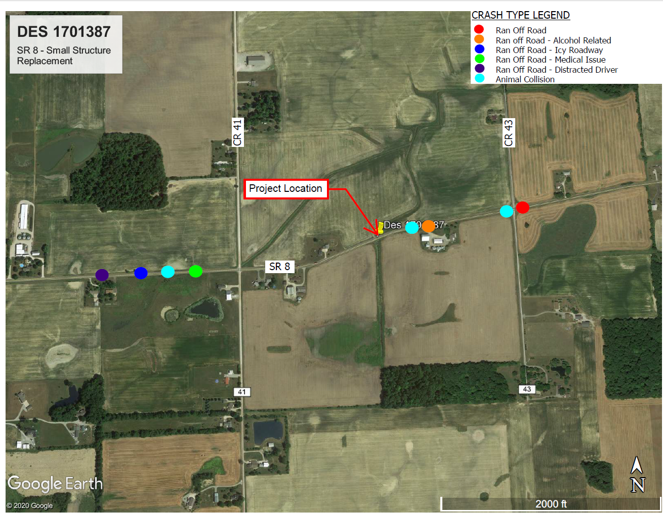
Crash data plotted on map example

